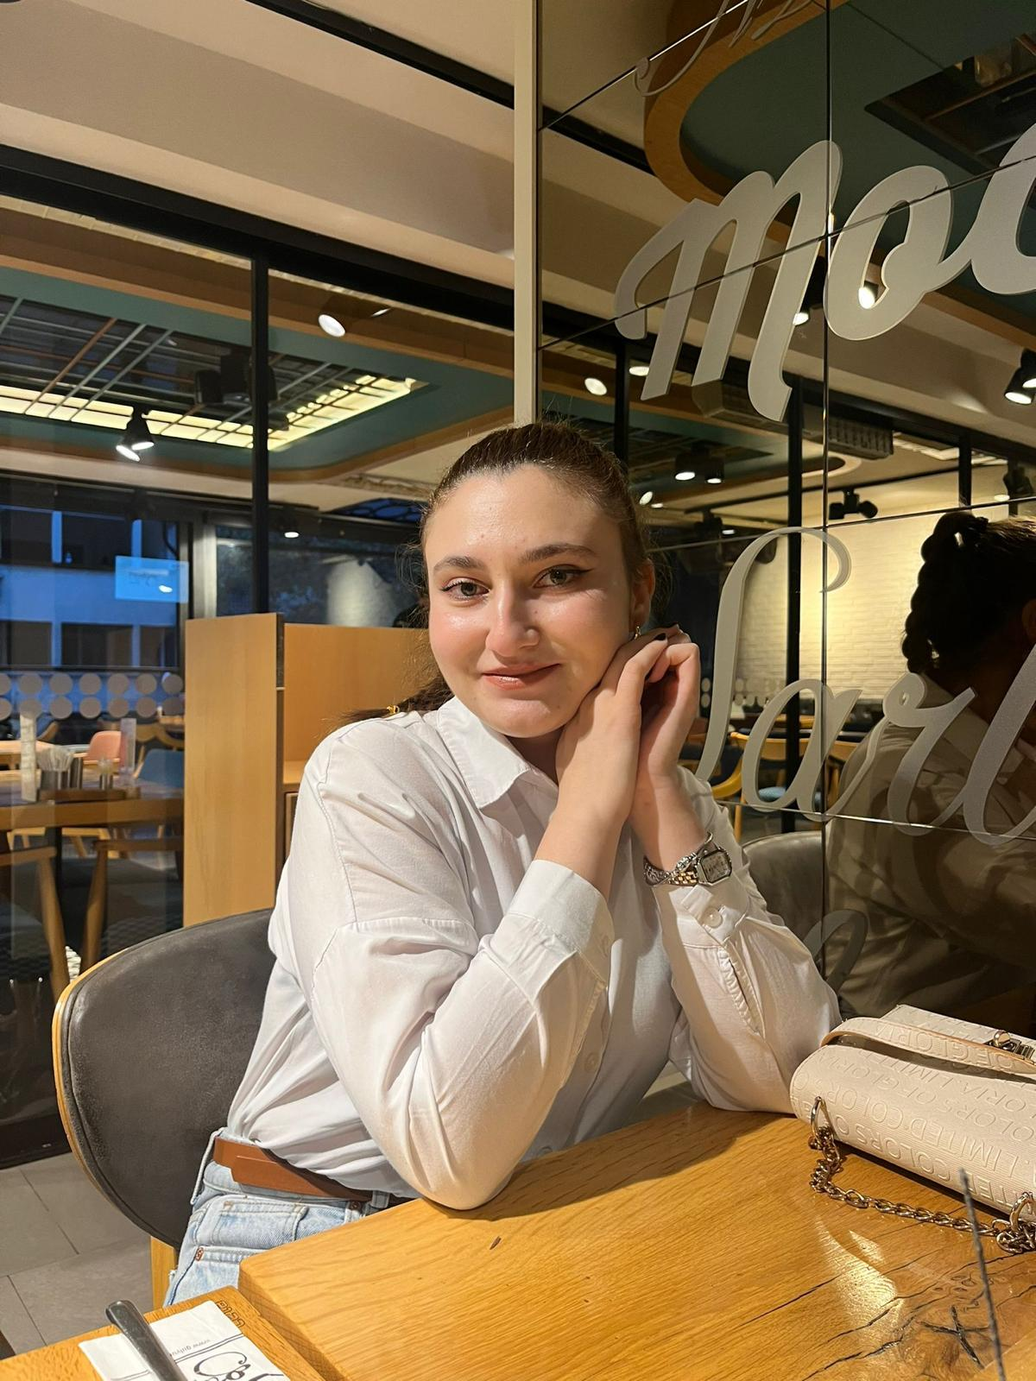PROFILE  Graduated from the English Language Teaching Department at Afyon Kocatepe University. Gained international academic and cultural experience through the Erasmus+ program in Poland. Experienced in teaching young learners at preschool, primary, and secondary levels through internships and private tutoring. Skilled in classroom management, material design, and student-centered teaching approaches. Passionate about creating engaging and effective learning environments for young learners.  CONTACT  Phone:  0533 019 4471  E-Mail:  Tyildirg12@gmail.com |  | filiz yıldırgan  English Teacher  EDUCATION  Afyon Kocatepe University – English Language Teaching (2021–2026)  Completed English preparatory year successfully.  Participated in Erasmus+ mobility program at the Catholic University of Lublin, Poland.  Provided private tutoring for primary and secondary school students.  Completed teaching internship at Girne College, Afyon.  Delivered presentations on teaching young learners and material development.  Kılıçarslan Anatolian High School (2017–2021)  - Graduated with a GPA of 87.32/100.  - Studied in the Foreign Language track and attended additional language courses.  19 Mayıs Primary and Secondary School (2009–2017)  WORK EXPERIENCE  Marla Daycare Center (Afyonkarahisar) – English Teacher (2025–2026)  - Planned and implemented English activities for preschool students.  - Designed age-appropriate materials to support permanent learning.  - Applied game-based learning techniques to increase student engagement.  REFERENCES  Marla daycare manager- Leyla Karaağaç  Contact: 0507 528 9791  Private Girne College- E. Deniz Dikbaş  Private Girne College English Teacher- Tuğba Doğan  Contact: 0544 641 9531  SKILLS  - Classroom Management  - Teaching Young Learners  - Material Design  - Lesson Planning  - Game-Based Learning  - Effective Communication  LANGUAGES  - English – Advanced  - German – Basic  - Polish – Basic

